Report – A Neural Network with forward and backward propagation, in Python.

BCSAI
Y1-Q1
Principles of Programming

Index
1- Introduction
2- Approach and Methodology
2.1 Problem & Strategy
2.2 Design Choices
Initialization
Indexing
Input/Output Data Structure
Forward/Backward Propagation
Gradient Descent (Stochastic Descent)
3- Programming Tools and Methods
3.1 Programming Techniques
3.2 Libraries
4- Results
4.1 Testing on MNIST Handwritten Digits Dataset
4.2 Testing the Effects of each Parameter
5- Future Goals

Introduction
The goal of this project was to create a simple Neural Network class that is capable of forward/backward propagation and gradient descent. The Neural Network should work on any given dataset, provided the data is formatted correctly. Given the scope of the project and the group’s programming experience, the goal was not to create a fully-fledged Neural Network library. The true objective of this project was to create a simple, functional Neural Network from the group up with Python and by doing so learn the math and key concepts of Neural Networks.

The overall development strategy was to study the math until it was intuitive, and then implement the idea in code. The Network class went through three iterations; a proof of concept Jupyter notebook, and two versions of the python class implementation. The final iteration can be used on any dataset provided the input matches the specified format.

Approach and Methodology

2.1 Problem & Strategy
The largest problem in this project was deciding exactly how we wanted to implement the program. The main question that we had to ask ourselves during development was: ‘do we want to implement this in the most Pythonic way, or the most mathematically correct way?’ Throughout the iterations, we made adjustments on this scale and eventually settled in a middle ground. The following design choices are a summary of where we landed on that scale for each feature.

2.2 Design Choices

Initialization
As the Network designed to be applicable in many situations, the initialization is intentionally kept simple. The only argument that is necessary is the ‘shape’ of the input layer and neurons of the network. However, we added the ability to choose the activation function for the hidden and output layers. So far, we only have one implemented, but if we decide to expand the project, it would be relatively simple to add other activation functions.
Examples of network class initialization:
Network(shape=[784, 128, 64, 10])
Initializes a network with 784 (input), 128, 64, (hidden), 10 (output) neurons.
Network(shape=[“], random_wb=True, af_hidden=’relu’, af_output=’softmax’)
Initializes a network with random weights and biases, that uses the relu function for activation of the hidden layers and softmax for the activation of the output layer.

Indexing
Indexing was the most significant conflict between Python and mathematical language. Technically, the input layer is not a ‘real’ layer in the system, as it is just a set of values. However, since we had to iterate through the layers (weights, biases, activation, etc.) both in the forward and backward direction for the respective propagations, it was important for all the layers to have the correct indices. In our second iteration of the project, we omitted the input layer from the ‘z’ (pre activation value) variable, which is mathematically correct (input layer has no pre-activation value). This had the effect of complicating the code as there had to be special ‘if’ controls for iterating over the first/last layer. In the final version, f_prop returns z with an empty array for element zero. This may seem like a small decision, but figuring out the indexing is what made the third iteration’s code significantly cleaner.

Input/Output Data Structure
x_train, x_test
The input (for training, testing) must be a numpy array with nested numpy arrays. The nested numpy arrays must each have the same number of elements as the size of the input layer in the network. The inputs must be normalized between -1 and 1.
y_train, y_test
The output must be in a numpy array containing consecutive integer values starting from 0. We considered adding functionality to map other values to consecutive integers so that the network can be used on any type of output, but we decided to keep the code simple. This is something that we intend on adding in the future.
Note that the input/output structure was inspired by our use of the MNIST dataset in class. It’s the same format, aside from the normalization of the x_train/x_test.

Forward/Backward Propagation
Since we took the time to learn the math before diving into the code, setting up the structure of the class was the most decision-intense part of the project. After we decided on the structure of the class, implementing these features were a simple matter of translating the math into python (see appendix for the math).

Gradient Descent (Stochastic Descent)
In our first iteration of the project, we did not do any batching when calculating the gradient descent. In the current iteration, there is a .get_gradient() method that calculates the optimal descent over all of the data passed to it. The .descend_stoc() method passes batches of data to the .get_gradient() method. It then updates the weights and biases and passes the next batch to .get_gradient(). We also implemented a .descend_full() method, but that is essentially the same thing as .descend_stoc() with the batch size being the full dataset.

Programming Tools and Methods
Description of the main programming techniques, libraries, algorithms, or tools used or developed.

3.1 Programming Techniques
Object oriented programming. The simplicity throughout this project can be attributed to the breakdown of Network Class into it’s separate functions. After each iteration, we had a clearer idea of how to separate different aspects of the Network into their respective methods. Each method of the Network class has a simple role, which keeps the code clean and allows for easy expansion.
We used AI (specifically Claude and ChatGPT) to check our code, but notably, the project’s first iteration was done by hand. AI’s main role in this was to debug quickly and efficiently. All design choices were made by the group without the use of AI.

3.2 Libraries
The only library used in this project is NumPy. NumPy allowed for fast implementation of linear algebra in Python.

Results

4.1 Testing on MNIST Handwritten Digits Dataset
The Network performs consistently well on the MNIST handwritten dataset. The largest gains are made in the first (approx.) 200 descents (at batch 32). Figure 1 shows the performance of the network on the MNIST handwritten network dataset.
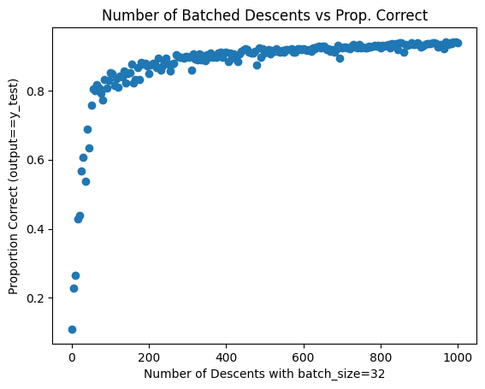
Figure 1

4.2 Testing the Effects of each Parameter

Aside from testing the accuracy of the network itself, this projects allows for investigation into how each parameter, such as batch size or learning rate (alpha), affect the learning rate of the network. Using the assistance of AI, we were able to generate a 3D plot that shows the relationship between the learning rate, proportion of x_test correctly identified, and the number of batched descents. Figure 2 shows us that (in this context), our Network performs best at a learning rate of between 0.2 to 0.8.

Although this analysis is rather simple, our focus in this project was on creating the network itself. We plan to continue investigating the optimization of the different parameters concerning neural networks using our own network module.
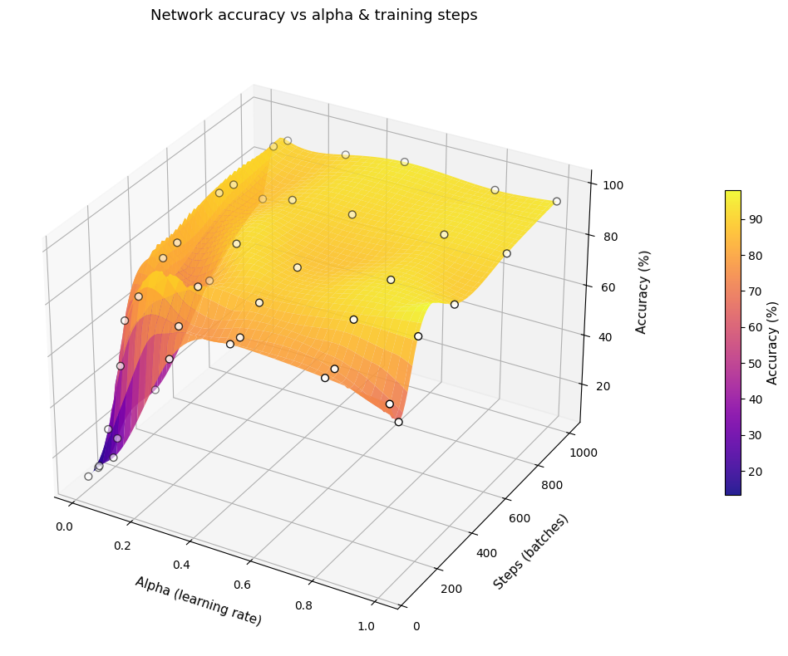
Figure 2

Future Goals
This project was meant to be an introduction into the mathematics and programming behind Neural Networks. As a group, we have decided to maintain this code and develop this into a fully-fledged library. Although it may be unreasonable to expect it to perform better than industry standard modules such as PyTorch, we have decided for the sake of learning to develop this further. First, we want to add features in Python that make the library easy to use for any problem. For example, we are currently using the network to solve statistical modeling problems in our ‘Simulating and Modeling to Understand Change’ class. The network is performing well, but it’s missing some key features such as output mapping, or handling of categorical variables. After the library has the desired features, our goal is to write aspects of the code in faster programming languages to increase performance.

On a personal note, this project was designed specifically so that we can use it in our future student projects and we hope that the intention shows in our design choices. Each method of the Network class is carefully explained in the docstrings for future reference and convenience.

